2025-2026
SELECT COURSE LIST

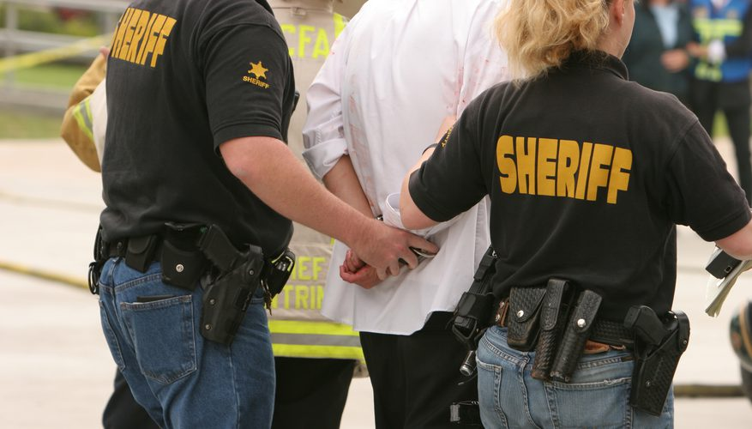

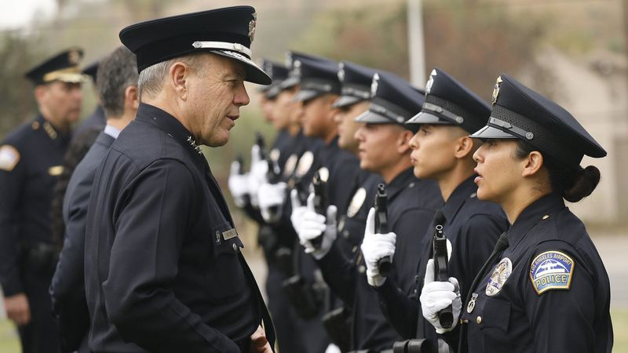

EXPERT TRAINING PROVIDED for:

CRIMINAL JUSTICE/LAW ENFORCEMENT
Corrections, and Private Security

Plus… PLACES OF WORSHIP, LIBRARIES

PUBLIC WORKS and PUBLIC/PRIVATE SECTOR

__________________________________________________________________________________________

Providing every student with the knowledge they seek and the training they require.

WWW.TRAININGFORCEUSA.COM

Most Classes are available as either In Person or Virtual Classes
TABLE OF CONTENTS

Table of Contents………………………………………………………………….Page Two

Investigation Classes………………………...………………………………...…. Page Three

Interview Classes…………………………………………………………………. Page Three

Investigations Using Technology………………………………………………….Page Four

Financial Crimes………………………...……………………………….………. Page Four

Leadership Classes………………………………………………………….....…..Page Five

Specially Priced Leadership Classes………………………………………………Page Six

Report Classes…………………. ...…………………………………………….... Page Six

Administration Classes………………………………………………………...…. Page Seven

General Law Enforcement Classes………………………………………………., Page Eight

Corrections Classes…………………………...………………………………….. Page Nine

Courtroom Classes………………………………………………………………...Page Nine

Diversity Classes………………………………………………………………... .Page Ten

Law Enforcement and Civilian Classes……………………………………...…...Page Eleven

Contact Info…………………………………………………………………. …. .Page Twelve

** Designates a NEW CLASS OFFERING

_____________________________________________________________________________
Course Descriptions for each class are available by calling 850-556-4544 or 850-251-1223
or via email: contactus@trainingforceusa.com
2
INVESTIGATION CLASSES

- INVESTIGATING! For LEOs and New Investigators (8 Hours)

- OVERDOSE DEATH INVESTIGATIONS (8 Hours)

- MS 13 (Mara Salvatrucha) (8 Hours)

- EYEWITNESS EVIDENCE IDENTIFICATION (8 Hours)
- SEX ASSAULT INVESTIGATION and INTERROGATION TACTICS (8 Hours)
- DOMESTIC VIOLENCE INVESTIGATIONS (8 Hours)
- HOMICIDE and MAJOR CASE INVESTIGATIONS (8 Hours)
- HUMAN TRAFFICKING: The Realities of Modern-Day Slavery (8 Hours)
- INTRO to SURVEILLANCE (8 Hours) **
- FLORIDA ORGANIZED CRIME (8 Hours) **

INTERVIEW CLASSES

- SYSTEMIC INTERROGATION METHOD (8 Hours)

- INTERVIEW and INTERROGATION TECHNIQUES (8 Hours)
- COGNITIVE INTERVIEWING (8 Hours) **

_____________________________________________________________________________
Course Descriptions for each class are available by calling 850-556-4544 or 850-251-1223
or via email: contactus@trainingforceusa.com 3
INVESTIGATIONS USING TECHNOLOGY CLASSES

- INVESTIGATING with DIGITAL FORENSICS (4 Hours)
- DARK WEB INVESTIGATIONS (8 Hours)
- SOCIAL MEDIA INVESTIGATIONS (4 Hours)
- ADVANCED TECHNOLOGY INVESTIGATIONS (8 Hours)
- E-DISCOVERY ELEMENTS (4 Hours)
- UNDERSTANDING and TRACING IP ADDRESSES (4 or 8 Hours)
- CELL PHONES and SOCIAL MEDIA RECORDS:
Working with Legal and Open-Source Information (16 Hours)
- ARTIFICIAL INTELLIGENCE (AI) ELEMENTS (8 Hours) **

FINANCIAL CRIMES CLASSES

- RICO and MONEY LAUNDERING INVESTIGATIONS (8 Hours)
- FINANCIAL DOCUMENT ANALYSIS! (8 or 16 Hours)
- HUNTING THE GHOST! Exposing, Investigating and Prosecuting Fraud (8 or 16 Hours)
- The Virtual World of CRYPTOCURRENCY (8 Hours)
- ALL ABOUT SKIMMERS! (8 Hours)
- ‘Tis the SEASON for FRAUD! (Holiday Season Crime) (8 Hours)
- CARD CRACKING and SCAM INVESTIGATIONS (3 Hours) **
- CHECK FRAUDS! (4 Hours) **

_____________________________________________________________________________
Course Descriptions for each class are available by calling 850-556-4544 or 850-251-1223
or via email: contactus@trainingforceusa.com 4

LEADERSHIP CLASSES

- LEADERSHIP COACHING SKILLS for FIRST LINE SUPERVISORS (8 Hours)

- SERVING with HONOR and INTEGRITY IN THE 21st CENTURY (8 Hours)
- SUP-HER-VISOR (8 Hours)
- SUPERVISOR ACADEMY (8 Hours) **
- SUPERVISING AN INVESTIGATIVE UNIT (8 Hours)
- UNDERSTANDING GENERATIONAL DIFFERENCES in the WORKPLACE (8 Hours)
- EMOTIONAL INTELLIGENCE: What it is, Why it is Important, How to Improve Yours (8 Hours)
- ULTIMATE ETHICS – In the Race of Life, Character is Destiny (8 Hours)
- ETHICS for CRIMINAL JUSTICE PROFESSIONALS (3 Hours)
- MASTERING LEADERSHIP DYNAMICS (8 Hours)
- MANAGERIAL STYLES and LEADERSHIP PRINCIPLES for TODAY’S LAW ENFORCEMENT PROFESSIONAL (8 Hours)

- MANAGEMENT vs LEADERSHIP: What Every Supervisor Should Know (8 Hours) **
- MASTER INSTRUCTOR (8 Hours) **
- TRANSFORMATIONAL LEADERSHIP: Creating Teams in the 21st Century (8 Hours) **

____________________________________________________________
Course Descriptions for each class are available by calling 850-556-4544 or 850-251-1223
or via email: contactus@trainingforceusa.com
5

SPECIALLY PRICED LEADERSHIP CONTRACTED CLASSES:

- EFFECTIVE TRAINING & TEACHING STRATEGIES FOR
THE NEXT GENERATIONS OF LEARNERS (16 Hours)

- MANAGING GENERATIONAL DIFFERENCES &
DEALING WITH PROBLEM EMPLOYEES (16 Hours)

- SPECIAL LEADERSHIP/SUPERVISOR TRAINING EVENT
Societal Trends, Dealing with Millennials and Creating High Performance Teams (16 Hours)
- U LEAD – Re-energize, Re-engage, Re-commit (8 hours)

- CHALLENGES FACING CRIMINAL JUSTICE LEADERS and SUPERVISORS (16 Hours)

REPORT CLASSES
- LEO REPORT WRITING: Dare to be Different (8 Hours)
- REPORT REVIEWS FOR SUPERVISORS (8 Hours)
- DEATH NOTIFICATIONS: Building Better Cases by Understanding the Reactions of Crime Victims (8 Hours)

_____________________________________________________________________________
Course Descriptions for each class are available by calling 850-556-4544 or 850-251-1223
or via email: contactus@trainingforceusa.com 6

ADMINISTRATION CLASSES

- OFFICER INVOLVED SHOOTINGS (8 Hours)
- INTERNAL AFFAIRS-Policies and Practice (8 Hours)
- Managing Professional Standards through STAFF INSPECTIONS (8 Hours)
- BUDGETING FOR LAW ENFORCEMENT PROFESSIONALS (8 Hours)
- USE OF FORCE ANALYSIS (8 Hours in person only)
- PROPERTY and EVIDENCE MANAGEMENT (8 Hours)

- OFFICER RIGHTS IN THE WORKPLACE & THE DECERTIFICATION PROCESS
Florida Specific (8 Hours)
- FLORIDA PUBLIC RECORDS LAW for LAW ENFORCEMENT (6 Hours)

- FLORIDA FORFEITURE! (8 Hours)

- COMMUNITY ENGAGEMENT and CREATING A CRIME PREVENTION UNIT (8 Hours) **
- FIELD TRAINING for DETECTIVES (24 Hours) **
- COMPLETE SEARCH and SEIZURE (8 Hours) **

__________________________________________________________________________
Course Descriptions for each class are available by calling 850-556-4544 or 850-251-1223
or via email: contactus@trainingforceusa.com 7

GENERAL LAW ENFORCEMENT CLASSES

- IMMIGRATION LAW- 4 OR 8 HOURS

- OFFICER AMBUSH ASSAULT AWARENESS…Lessons Learned (8 Hours)
- CRISIS INTERVENTION AND DE-ESCALATION SKILLS PROMOTING OFFICER SAFETY
This is NOT a hands-on training. (8 Hours)
- CRIME SCENE DOCUMENTATION (4 Hours)
- RESPONDING to VETERANS in CRISIS (8 Hours)
- LAW ENFORCEMENT OFFICER WELLNESS and RESILIENCY
(This Job Can be a Killer, Even if No One is Shooting at You) (8 Hours)
- IN HARMS WAY: Building Resiliency Against Psychological, Emotional and Physical Toll of Traumatic Stress, PTSD, Compassion Fatigue and Burnout Among First Responders (8 Hours)

- Critical Incident Stress Management/CISM-ATSM: PREPARING FOR THE UNIMAGINABLE
for Law Enforcement / Correctional Personnel / 911 Operators / First Responders (16 Hours)
- Responding To People with Mental Health Issues and Disabilities; Crisis Intervention, Verbal De-escalation, C I T Skills and Officer Safety (8 Hours)

- INTERPERSONAL SKILLS FOR LAW ENFORCEMENT OFFICERS: A Comprehensive Guide To Persuasive and Effective Communication and Customer Service (8 Hours)
- STALLING FOR TIME: Crisis/Hostage Negotiation Skills for First Officers on the Scene (8 Hours)
- Advanced UAS (Drone) OPERATIONS for LAW ENFORCEMENT (16 Hours)
- PREPARING to PASS the FAA UAG Part 107 DRONE LICENSE EXAM (8 Hours)
- TECHNICAL SPANISH for PUBLIC SAFETY (8 Hours or 16 Hours) **
- SEARCH WARRANTS 101: The Essentials (8 Hours) **
- ELDERLY NEGLECT, ABUSE and EXPLOITATION (8 Hours) **
- DRUG IDENTIFICATION and EMERGING TRENDS (8 Hours) **
- THE NOSE KNOWS! Effective and Efficient K-9 Scent Detection Techniques (8 Hours) **
- FIELD TRAINING for DETECTIVES (24 Hours in person) **
- INTERNATIONAL GANGS: MS-13, 18th Street, Tren de Aragua & MORE (8 Hours) **
__________________________________________________________________________
Course Descriptions for each class are available by calling 850-556-4544 or 850-251-1223
or via email: contactus@trainingforceusa.com
8

CORRECTIONS CLASSES

- PRISON RAPE & SEX ASSAULT INVESTIGATIONS
Inside CORRECTIONAL FACILITIES (PREA Training) (8 Hours)
- WEARING THE BADGE BEHIND BARS: Wellness – Safety – Building Resiliency (8 Hours)

- GAMES INMATES PLAY and CORRECTIONAL INFLUENCE (8 Hours)
- BASIC CRISIS NEGOTIATIONS SKILLS FOR CORRECTIONAL OFFICERS (8 Hours)

COURTROOM RELATED CLASSES

- COURTROOM KARATE (Courtroom Testimony Training) (8 Hours)
- SEARCH WARRANTS 101 : The Essentials (8 Hours)
- HAUNTED BY THEIR WORK:
Judges, Attorneys, Court Staff and Jurors can be Affected by What They See and Hear in the Courtroom. Understanding Vicarious Trauma, Stress, Compassion Fatigue and PTSD (4 Hours)

__________________________________________________________________________
Course Descriptions for each class are available by calling 850-556-4544 or 850-251-1223
or via email: contactus@trainingforceusa.com
9

DIVERSITY CLASSES

- SEXUAL HARASSMENT – Creating and Maintaining Safe and Professional Work Environments
(8 Hours)
- CULTURAL COMPETENCY for LAW ENFORCEMENT AGENCIES: A Commitment to Diversity, Equity and Inclusion (8 Hours)
- DIVERSITY: DEPTH and PERSPECTIVE (8 Hours)
- RESPONDING TO LESBIAN, GAY, BISEXUAL and TRANSGENDER VICTIMS OF CRIME
(8 Hours)

__________________________________________________________________________
Course Descriptions for each class are available by calling 850-556-4544 or 850-251-1223
or via email: contactus@trainingforceusa.com
10

LAW ENFORCEMENT, PRIVATE SECURITY, AND CIVILIAN CLASSES

- COMM CENTER WELLNESS: Building Resiliency So You Don’t Come Unplugged (4 Hours)
- SCHOOL and CAMPUS VIOLENCE AWARENESS – Prevention – Intervention – Response
(8 Hours)
- A SENSIBLE APPROACH to an ACTIVE SHOOTER and VIOLENT BEHAVIOR (8 Hours)
- CHILD ABUSE PROTECTION, SAFETY AND ABUSE PREVENTION For Places of Worship Staff and Volunteers (8 Hours)
- VIOLENCE IN THE WORKPLACE and PUBLIC PLACES: Are You Prepared (8 Hours)

- CRISIS RESPONSE PLANNING FOR THE HOSPITALITY INDUSTRY (8 Hours)
- A SENSIBLE RESPONSE FOR SAFETY AND SECURITY FOR PLACES OF WORSHIP (8 Hours)

- LIBRARY SAFETY AND SECURITY: Keeping Staff, Patrons, and Property Safe (8 Hours)

- COMPASSION FATIGUE: How To Continue To Burn Bright Without Burning Out The Cost of Caring – Awareness, Prevention, Recovery and Building Resiliency (8 Hours)

- DE-ESCALATION TACTICS and SKILLS FOR OFFICER SAFETY (8 Hours)

- Critical Incident Stress Management CISM Skills for Security Officers (16 Hours)
- LEO to CIVILIAN (4 Hours) **

__________________________________________________________________________
Course Descriptions for each class are available by calling 850-556-4544 or 850-251-1223
or via email: contactus@trainingforceusa.com
11



FOR MORE INFORMATION ON THESE CLASSES
AND/OR TO HOST OR PURCHASE A CLASS, PLEASE CONTACT US:

1-850-556-4544 or 1-850-251-1223
contactus@trainingforceusa.com

WWW.TRAININGFORCEUSA.COM

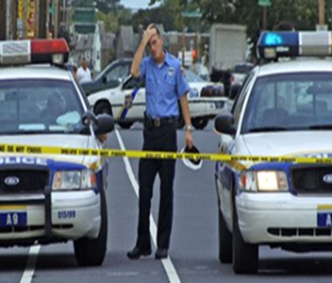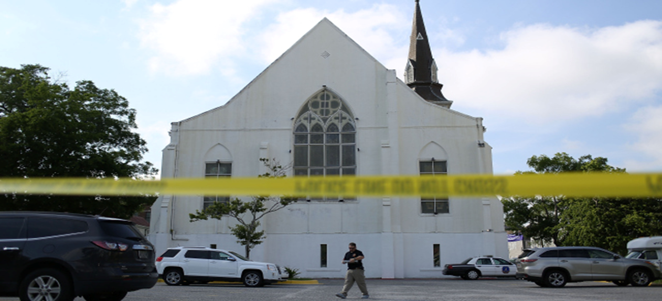

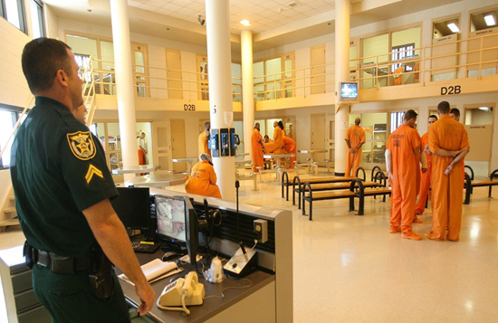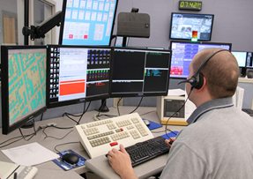

12

